**

**Mathematics Specialist Unit 1**

# Test 4

**Trigonometry**

|  |
| --- |
| **Name: ______________________ Total Marks:__________** |
|  |
|  |

**Task type: Response**

**Time allowed for this task:** 60 minutes, in-class, under test conditions

Section One: Calculator-free 30 minutes ( 30marks)

Section Two: Calculator-assumed 30minutes ( 30marks)

**Materials required:** Calculator with CAS capability (to be provided by the student)

**Standard items:** Pens (blue/black preferred), pencils (including coloured), sharpener, correction fluid/tape, eraser, ruler, highlighters

**Special items:**  Drawing instruments, templates, notes on one unfolded sheet of   
A4 paper, and up to three calculators approved for use in the WACE examinations

Formula sheet

**Marks available: 60 marks**

**Task weighting: 7%**

**Section One : Calculator Free 30 Marks**

**Time Allowed 30 minutes**

**Question 1**

**[7 marks]**

1. Solve for $x$ in ${3sec}^{2}{x=}4$ for $0≤x≤2π$

[3 marks]

1. Find all the solutions (in radians) for x in $2\sin\left(x-\frac{π}{2}\right)=-1$

[4 marks]

**Question 2**

**[4 marks]**

Find $θ$ in $2\sin^{2}{θ+\cos{θ=2}} for 0≤x≤2π$

**Question 3**

**[6 marks]**

On the grids below sketch the following graphs of

$y=3\cos{(2x)}$

[3 marks]

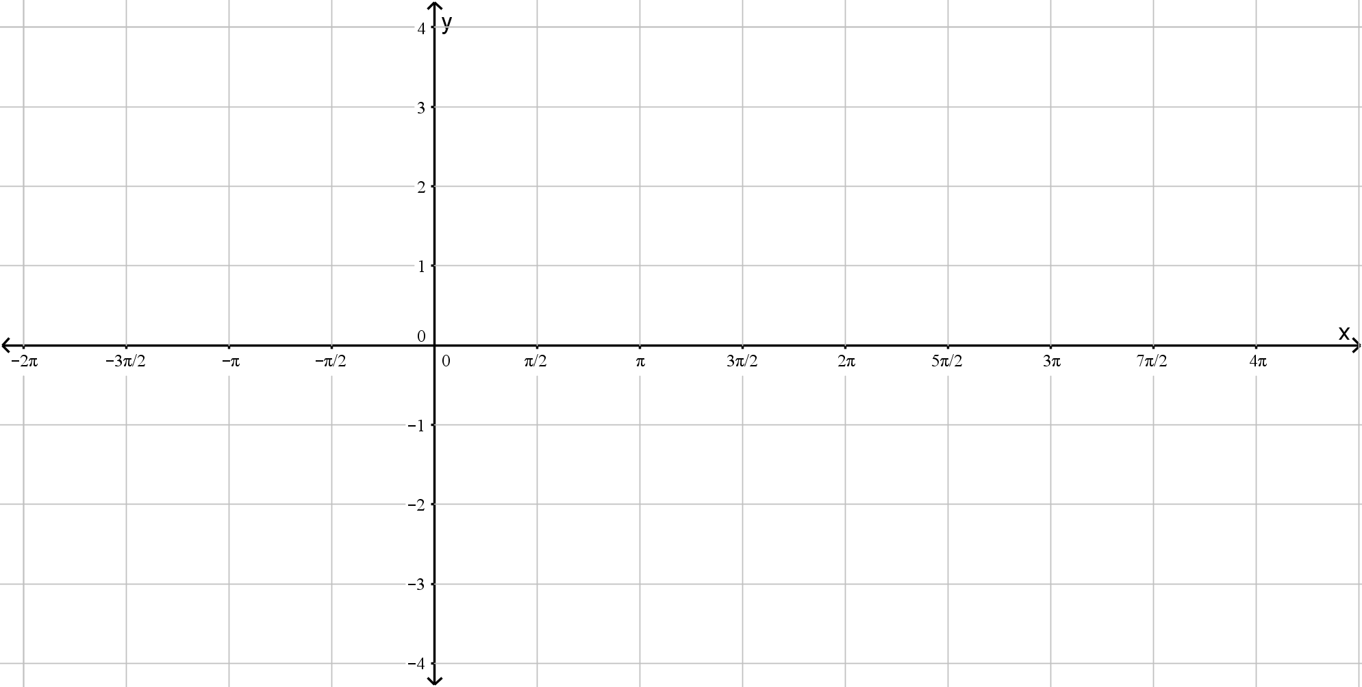

$y=cosec({x)-1}$

[3 marks]



**Question 4**

**[4 marks]**

Evaluate:

$cos75°cos15°.$

[2 marks]

$\sin{\frac{11π}{12}}\sin{\frac{π}{12}}$

[2 marks]

**Question 5**

**[9 marks]**

Prove that, for $\cos{x≠0}$,

$\sin{2x}-\tan{x}≡\tan{x\cos{2x}}$

[5 marks]

Hence, or otherwise, solve the equation

$$\sin{2x}-\tan{x}≡\sqrt{3}\cos{2x}$$

For $0≤x≤180°$

[4 marks]

**Section Two : Calculator Assumed 30 Marks**

**Time Allowed 30 minutes Name:_______________________**

**Question 6**

**[9 marks]**

Given that

$$\sin{A=\frac{3}{5}} and \tan{B=-\frac{1}{2}, where A and B are obtuse,}$$

use appropriate trigonometric identities to find the exact value of:

$\cos{A}$

[1 mark]

$\tan{A}$

[1 mark]

$\sin{2A}$

[2 marks]

$\tan{(A+B)}$

[2 marks]

$\cos{(A+B)}$

[3 marks]

**Question 7**

**[9 marks]**

1. Express $2\sin{x}-3\cos{x}$ in the form $R\sin\left(x-α\right)$ where $R>0$ and $0<α<90°$. Hence find the exact value or $R$ and $α$ to two decimal places.

[3 marks]

1. Show that the equation $\operatorname{cosec}{x}+3\cot{x}=2$ can be written in the form $2\sin{x}-3\cos{x=1}$

[3 marks]

1. Solve the equation $\operatorname{cosec}{x}+3\cot{x}=2$ for $0<x<360°$ giving your answers to one decimal place.

[3 marks]

**Question 8**

**[12 marks]**

Prove the following identities

$\sec^{2}{θ}=\sec{θ}\operatorname{cosec}{θ}\tan{θ}$

[3 marks]

$\sin\left(3θ\right)=3\sin{θ-4\sin^{3}{θ}}$

[4 marks]

$2\cot\left(2θ\right)+\tan{θ}≡\cot{θ}$

[5 marks]